**Wideband Delphi Technique**

In Wideband Delphi Technique, the estimation team comprises of the project manager, moderator, experts, and representatives from the development team, constituting a 3-7 member team. There are two meetings which are ; The Kickoff Meeting and Estimation Meeting

**Wideband Delphi Technique – Steps**

**Steps**

1. Choose the Estimation team and a moderator.
2. The moderator conducts the kickoff meeting, in which the team is presented with the problem specification and a high level task list, any assumptions or project constraints. The team discusses on the problem and estimation issues, if any. They also decide on the units of estimation. The moderator guides the entire discussion, monitors time and after the kickoff meeting, prepares a structured document containing problem specification, high level task list, assumptions, and the units of estimation that are decided. He then forwards copies of this document for the next step.
3. Each Estimation team member then individually generates a detailed WBS, estimates each task in the WBS, and documents the assumptions made.
4. The moderator calls the Estimation team for the Estimation meeting. If any of the Estimation team members respond saying that the estimates are not ready, the moderator gives more time and resends the Meeting Invite.
5. The entire Estimation team assembles for the estimation meeting.
6. At the beginning of the Estimation meeting, the moderator collects the initial estimates from each of the team members.
7. He then plots a chart on the whiteboard. He plots each member’s total project estimate as an X on the Round 1 line, without disclosing the corresponding names. The Estimation team gets an idea of the range of estimates, which initially may be large.
8. Each team member reads aloud the detailed task list that he/she made, identifying any assumptions made and raising any questions or issues. The task estimates are not disclosed.
9. The individual detailed task lists contribute to a more complete task list when combined.
10. The team then discusses any doubt/problem they have about the tasks they have arrived at, assumptions made, and estimation issues.
11. Each team member then revisits his/her task list and assumptions, and makes changes if necessary. The task estimates also may require adjustments based on the discussion, which are noted as +N Hrs. for more effort and –N Hrs. for less effort.
12. The team members then combine the changes in the task estimates to arrive at the total project estimate.
13. The moderator collects the changed estimates from all the team members and plots them on the Round 2 line.
14. In this round, the range will be narrower compared to the earlier one, as it is more consensus based.
15. The team then discusses the task modifications they have made and the assumptions.
16. Each team member then revisits his/her task list and assumptions, and makes changes if necessary. The task estimates may also require adjustments based on the discussion.
17. The team members then once again combine the changes in the task estimate to arrive at the total project estimate.
18. The moderator collects the changed estimates from all the members again and plots them on the Round 3 line.
19. Again, in this round, the range will be narrower compared to the earlier one.
20. Steps 17, 18, 19 are repeated till one of the following criteria is met −

* Results are converged to an acceptably narrow range.
* All team members are unwilling to change their latest estimates.
* The allotted Estimation meeting time is over.

1. The Project Manager then assembles the results from the Estimation meeting.
2. He compiles the individual task lists and the corresponding estimates into a single master task list.
3. He also combines the individual lists of assumptions.
4. He then reviews the final task list with the Estimation team.

**Advantages**

* Wideband Delphi Technique is a consensus-based estimation technique for estimating effort.
* Useful when estimating time to do a task.
* Participation of experienced people and they individually estimating would lead to reliable results.
* People who would do the work are making estimates thus making valid estimates.
* Anonymity maintained throughout makes it possible for everyone to express their results confidently.
* A very simple technique.
* Assumptions are documented, discussed and agreed.

**Disadvantages**

* Management support is required.
* The estimation results may not be what the management wants to hear.

**Three-point Estimation Technique**

Three-point Estimation looks at three values

* the most optimistic estimate (O),
* a most likely estimate (M), and
* a pessimistic estimate (least likely estimate (L)).

There has been some confusion regarding Three-point Estimation and PERT in the industry. However, the techniques are different. You will see the differences as you learn the two techniques. Also, at the end of the PERT technique, the differences are collated and presented. If you want to look at them first, you can.

Three-point Estimate (E) is based on the simple average and follows triangular distribution.

**E = (O + M + L) / 3**

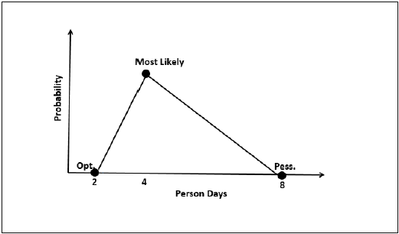

Standard Deviation

In Triangular Distribution,

Mean = (O + M + L) / 3

Standard Deviation = √ [((O − E)2 + (M − E)2 + (L − E)2) / 2]

Three-point Estimation Steps

**Step 1** − Arrive at the WBS.

**Step 2** − For each task, find three values − most optimistic estimate (O), a most likely estimate (M), and a pessimistic estimate (L).

**Step 3** − Calculate the Mean of the three values.

**Mean = (O + M + L) / 3**

**Step 4** − Calculate the Three-point Estimate of the task. Three-point Estimate is the Mean. Hence,

**E = Mean = (O + M + L) / 3**

**Step 5** − Calculate the Standard Deviation of the task.

**Standard Deviation (SD) = √ [((O − E)2 + (M − E)2 + (L - E)2)/2]**

**Step 6** − Repeat Steps 2, 3, 4 for all the Tasks in the WBS.

**Step 7** − Calculate the Three-point Estimate of the project.

**E (Project) = ∑ E (Task)**

**Step 8** − Calculate the Standard Deviation of the project.

**SD (Project) = √ (∑SD (Task)2)**

Convert the Project Estimates to Confidence Levels

The Three-point Estimate (E) and the Standard Deviation (SD) thus calculated are used to convert the project estimates to “Confidence Levels”.

The conversion is based such that −

* Confidence Level in E +/– SD is approximately 68%.
* Confidence Level in E value +/– 1.645 × SD is approximately 90%.
* Confidence Level in E value +/– 2 × SD is approximately 95%.
* Confidence Level in E value +/– 3 × SD is approximately 99.7%.

Commonly, the 95% Confidence Level, i.e., E Value + 2 × SD, is used for all project and task estimates.

Project Evaluation and Review Technique (PERT)

Project Evaluation and Review Technique (PERT) estimation considers three values: the most optimistic estimate (O), a most likely estimate (M), and a pessimistic estimate (least likely estimate (L)). There has been some confusion regarding Three-point Estimation and PERT in the Industry. However, the techniques are different. You will see the differences as you learn the two techniques. Also, at the end of this chapter, the differences are collated and presented.

PERT is based on three values − most optimistic estimate (O), a most likely estimate (M), and a pessimistic estimate (least likely estimate (L)). The most-likely estimate is weighted 4 times more than the other two estimates (optimistic and pessimistic).

PERT Estimate (E) is based on the weighted average and follows beta distribution.

**E = (O + 4 × M + L)/6**

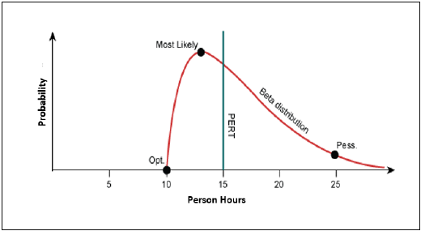

PERT is frequently used along with Critical Path Method (CPM). CPM tells about the tasks that are critical in the project. If there is a delay in these tasks, the project gets delayed.

Standard Deviation

Standard Deviation (SD) measures the variability or uncertainty in the estimate.

In beta distribution,

Mean = (O + 4 × M + L)/6

Standard Deviation (SD) = (L − O)/6

PERT Estimation Steps

**Step (1)** − Arrive at the WBS.

**Step (2)** − For each task, find three values most optimistic estimate (O), a most likely estimate (M), and a pessimistic estimate (L).

**Step (3)** − PERT Mean = (O + 4 × M + L)/6

PERT Mean = (O + 4 × M + L)/3

**Step (4)** − Calculate the Standard Deviation of the task.

Standard Deviation (SD) = (L − O)/6

**Step (6)** − Repeat steps 2, 3, 4 for all the tasks in the WBS.

**Step (7)** − Calculate the PERT estimate of the project.

E (Project) = ∑ E (Task)

**Step (8)** − Calculate the Standard Deviation of the project.

SD (Project) = √ (ΣSD (Task)2)

Convert the Project Estimates to Confidence Levels

PERT Estimate (E) and Standard Deviation (SD) thus calculated are used to convert the project estimates to confidence levels.

The conversion is based such that

* Confidence level in E +/– SD is approximately 68%.
* Confidence level in E value +/– 1.645 × SD is approximately 90%.
* Confidence level in E value +/– 2 × SD is approximately 95%.
* Confidence level in E value +/– 3 × SD is approximately 99.7%.

Commonly, the 95% confidence level, i.e., E Value + 2 × SD, is used for all project and task estimates.